ASSESSMENT POLICY IN THE CLASSES
IMPLEMENTING THE INTERNATIONAL BACCALAUREATE DIPLOMA PROGRAMME AT THE XXXV LICEUM OGÓLNOKSZTAŁCE Z ODDZIAŁAMI DWUJĘZYCZNYMI IM. BOLESŁAWA PRUSA
IN WARSAW

- During the two-year International Baccalaureate Diploma Programme, students are required to:
1) complete six subjects from at least 5 subject groups designated by the International Baccalaureate Organization;
2) obtain a positive grade in the final examination in each of the selected subjects;
3) complete the core requirements, i.e.: Theory of Knowledge (TOK), Creativity, Activity, Service (CAS) and Extended Essay (EE).
- The students' final examination consists of components assessed both internally and externally, according to the criteria established by the International Baccalaureate Organization in the syllabuses for individual subjects.
- Internal Assessment is conducted during the course of study by the subject teacher and is subject to external moderation by an International Baccalaureate Organization examiner. It accounts for approximately 20-30% of the final grade. Depending on the subject, the following is assessed:
1) written essays;
2) oral presentations;
3) experiments and research work.
Completing the Internal Assessment requirements within the prescribed period is necessary to be eligible to take the External Assessment in a given subject.
- External Assessment - assessment of the written examination papers - is made by external examiners of the International Baccalaureate Organization and accounts for approximately 70-80% of the final grade.
- In addition, two main types of intra-school assessment are used in the two-year International Baccalaureate Diploma Programme:
- continuous assessment, which includes elements of formative assessment and the aim of which is to inform students about the progress they are making and the goals they have achieved as well as potential mistakes that should be corrected and to teach them to learn from mistakes made in the learning process.
This type of assessment is used continuously throughout each semester.
- summative assessment, the aim of which is to assess the progress achieved by students before proceeding to the next field, section of material or module.
Summative grades are information about the level of advancement of a student after a given stage of teaching and learning.
- In grading, the scale used by the International Baccalaureate Organization is applied, expressed in numbers 1 - 7, where 1 is the lowest mark and 7 the highest.
Symbol | Grade | Percentage
7 | Excellent | 100%-95%
6 | Very good | 94%-85%
5 | Good | 84%-75%
4 | Satisfactory | 74%-60%
3 | Mediocre | 59%-50%
2 | Poor | 49%-40%
1 | Very poor | 39%-0%

Theory of Knowledge (TOK) and Extended Essay (EE) are each graded in one of the following bands:

N | No grade
E | Elementary (Fail)
D | Mediocre
C | Satisfactory
B | Good
A | Excellent

- The minimum number of marks in a subject on the basis of which a student's term / annual grade is awarded is:
1) for an SL level subject: 5;
2) for an HL subject: 7.
- Due to the specificity of the International Baccalaureate Diploma Programme, 3 partial marks in each subject must be awarded for tasks of an exam type. This provision does not apply to the implementation of TOK and CAS.
- The number and form of oral and written works is specified in subject guides published by the International Baccalaureate Organization.
- Class works are compulsory. If a student has not written a class work, he or she is obliged to demonstrate their knowledge of its content within the time limit and in the form agreed on with the teacher of the subject.
- The student is obliged to evaluate their results throughout the duration of the IB DP Programme in order to monitor their progress and increase the results of subsequent tests, projects, research works.
- The student is obliged to meet all deadlines, deliver their work on time and take responsibility for any shortcomings. Each failure to meet the deadline set by the IB teachers will result in a reduction in the grade for a given credit, project or even the mid-year / annual grade from a given subject.
- The student's absences from classes, resulting from participation in obligatory projects provided for in the International Baccalaureate Diploma Programme, exchanges, trips or other forms of activities organized by the school, are not included in the pool of absences.
- If a student misses 25% or more classes of a given subject, the teacher has the right to conduct a written attendance test, respecting the following rules:
- if an attendance test has already been carried out in a given subject, then the absences that are the basis for the appointment of the next test are counted from the date of the first notification of the student or parent / legal guardian about the last attendance test;
- the notification is considered to be effectively served when the student or their parent / legal guardian have been notified directly at school or information has been sent via the e-journal Librus;
- the fact of notifying the student or parent / legal guardian is noted in the e-journal;
- the date of the test and the scope of the material are appointed by the subject teacher, and the grade determined by them is final;
- the form and criteria of the attendance test assessment are determined by the subject teacher in accordance with the provisions in the ‘Assessment Rules applied in the IB DP’ classes;
- in case of the student's excused absence, a new test date is appointed for the test, while an unexcused absence is tantamount to the student taking the test in the next class of the given subject.
- At the end of each semester grades are converted from the IB DP 1-7 scale to the 1-6 scale in place at school. The conversion of grades is as follows:
Grade in the IB DP course | Equivalent on an intra-school scale
7 | 6
6 | 5
5 | 4
4 | 3
3 | 2
2 | 1
1 | 1

- At the end of each school year, a student pursuing the International Baccalaureate Diploma Programme receives a promotion certificate to the next year or a school leaving certificate with grades on a scale from 1 to 6.
- If a student does not comply with the requirements of the International Baccalaureate Programme on an ongoing basis, teachers, as part of the mid-year information, prepare the so-called "Warning letters" for the attention of the student and parents / legal guardians.
- If a student in a class implementing the International Baccalaureate Diploma Programme does not meet the conditions for obtaining a diploma specified in the International Baccalaureate Organization documents, has low attendance, a below-acceptable behaviour grade or their attitude is not in line with the IB learner profile, they may be removed from the International Baccalaureate Diploma Programme at any stage of its implementation.
- In particularly justified cases (i.e. chronic illness, change of place of residence), the student may apply to the school principal to re-take one year of the Programme.
- A student in the International Baccalaureate Diploma Programme may not be admitted to participate in the examination session if the International Baccalaureate Diploma Programme staff decide that the student does not meet the requirements for obtaining the International Baccalaureate Diploma.
- A student who changes school, class, subject, resigns or has been removed from the International Baccalaureate Diploma Programme must compensate for curricular differences if there is a curricular difference in the teaching content of a subject. Passing such tests is the basis for transferring the student to another class at school, one not implementing the International Baccalaureate Diploma Programme. The rules for conducting the test are the same as for a classification exam, but the date of the test is set in the last week of the summer holidays.
- If there are no grounds for establishing an annual classification grade due to the student's absence from classes in a given subject for more than half of the time allocated to these classes in the school curriculum, the student may be not classified in that subject. In such a case, in the documentation of the course of teaching, instead of a classification grade, the entry "not classified" is written.
- A student who has not been classified due to an excused absence may take a classification exam. If a student is not classified due to an unexcused absence, they or their parents (legal guardians) may submit an application to the Teacher’s board, in which they ask for a classification examination. The Teacher’s board, taking into account the situation of the student, may set a date for the classification examination or refuse to grant it. The decision of the Teacher’s board is final. The application should be submitted before the classification meeting of the Teacher’s board.
- The classification examination is both written and oral and is carried out at a time agreed with the student and their parents (legal guardians), no later than on the day preceding the end of the school year. Detailed rules regarding the examination are defined in the ‘Assessment Rules applied in the IB DP’ and in the School Policy.
- If, due to force majeure, the student was unable to attend the classificatory exam within the prescribed period, they may take it on an additional date set by the school principal.
- Due to the necessity to inform parents (legal guardians) about the learning outcomes and students' behavior, parents (legal guardians) are obliged to be present at parents’ meetings appointed by the school principal. In special situations the class teacher determines an additional date for the meeting. Parents (legal guardians) who do not participate in open school days and meetings with parents or fail to contact the class teacher and subject teachers regarding their child’s learning process, may not, under any circumstances, appeal due to the lack of information about their child’s progress and their mid-term or final grades. This includes questioning the grade in a given subject.
- Students in the International Baccalaureate Diploma Programme take mock exams on a date set by the IB coordinator.
- Predicted grades are the grades in individual subjects teachers expect a student to achieve as a result of the final internal and external assessment at the end of the two year Diploma Programme.
- The subject predicted grades are based on the student’s work to date and might be taken into consideration by universities in the recruitment process.
- The examination session takes place in May at the student's school.
- The student has to take exams in 6 subjects which he has chosen at the start of the programme at the level at which they have studied them. A student can get a maximum of 42 points from the exams. Additionally, maximum 3 points can be obtained by a student for their results in Extended Essay and Theory of Knowledge. These points are calculated according to the following scale:
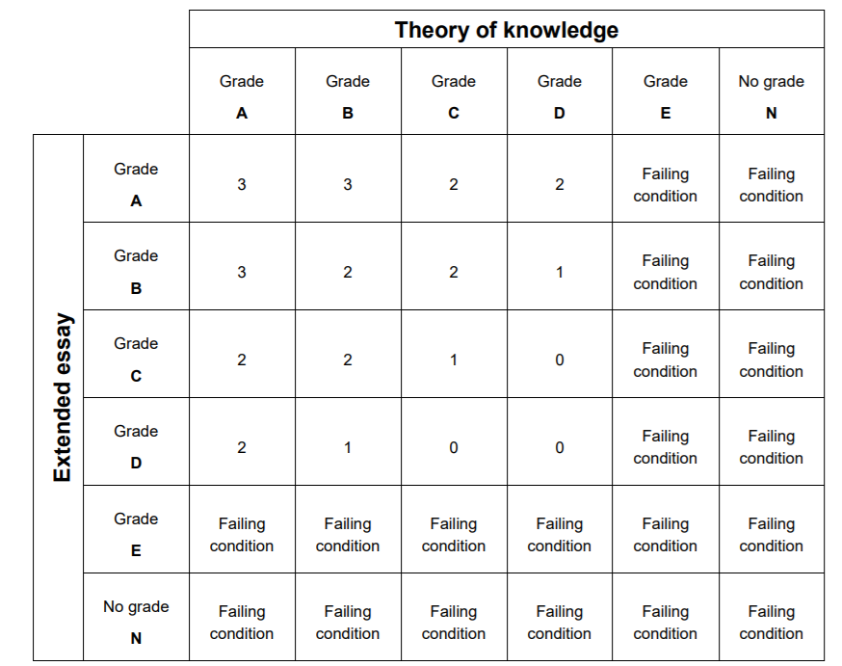
- In order to complete the programme and receive an IB diploma, the student has to obtain at least 24 points in their exams, as well as:
- make sure CAS requirements have been met,
- receive a grade other than “N” in TOK , EE or any contributing subject,
- receive a grade higher than E in TOK and/or EE,
- receive a grade higher than 1 in every subject,
- receive no more than two grade 2s (HL or SL) and no more than three grade 3s or below (HL or SL),
- receive at least 12 points in HL subjects (for students who register for four HL subjects, the three highest grades count) and 9 points in SL subjects (students completing only 2 SL subjects are required to receive at least 5 points in them),
- not receive a penalty for academic misconduct awarded by the Final Award Committee.
- A student who at the end of the IB Diploma Program has had their conduct rated as very good and who has received 34 or more points in their exams is distinguished with a special school diploma and a reward.

This document has been prepared and modified as a result of the analysis of students' needs
and expectations by a team of teachers involved in the IB DP.

In the preparation of this document Ustawa Prawo oświatowe (The Act on Educational Law) (Dz. U. 2017 poz. 59) of 14th December 2016 with further changes, „Statut XXXV Liceum Ogólnokształcącego z Oddziałami Dwujęzycznymi im. Bolesława Prusa w Warszawie” (The School Policy at the XXXV Liceum Ogólnokształcące z Oddziałami Dwujęzycznymi im. Bolesława Prusa In Warsaw), „Przedmiotowe Zasady Oceniania obowiązujące w oddziałach międzynarodowych, realizujących dwuletni Programme IB DP w XXXV Liceum Ogólnokształcącym z Oddziałami Dwujęzycznymi im. Bolesława Prusa w Warszawie” (“Assessment Rules applied in the classes implementing the two-year International Baccalaureate Diploma Programme at the XXXV Liceum Ogólnokształcące z Oddziałami Dwujęzycznymi im. Bolesława Prusa in Warsaw”) and the following IBO publications have been used: International Baccalaureate Organisation, Guidelines for developing a school assessment policy in the Diploma Programme (International Baccalaureate Organisation, 2010), International Baccalaureate Organisation, The Diploma Programme: From principles to practice (IB Publishing Ltd, 2015), International Baccalaureate Organisation, Diploma Programme Assessment procedures 2021 (Peterson House, 2021).

(─) Koordynator IB DP (─) Dyrektor
w XXXV Liceum Ogólnokształcącym XXXV Liceum Ogólnokształcącego
z Oddziałami Dwujęzycznymi im. Bolesława Prusa z Oddziałami Dwujęzycznymi
m. Bolesława Prusa

